

EXTRA SERIOUS COMPANY LTD

INCIDENT MANAGEMENT SYSTEM

TABLE OF CONTENTS

PROJECT DESCRIPTION 3

Workflow 3-4

Wireframes 5

Login screen 5

Dashboard 5

Incidence details 6

Screenshots 7

Database users’ collection 7

Incidents collection 7

Incidents loaded on the system 8

Incident details window display 8

Incident creation window 9

User account creation window 9

Dashboard 10

Code snippets 11

Incidents component 12

Incidents routes 13

Backend server 15

Future functionalities 16

Project URL 16

# PROJECT DESCRIPTION

Incident management system will used in managing customer incidences. The system will have users. Users will be required to register before using the system. Users will be able to add incidences, give comments on the incidences and change the incidence status.

The system will have a dashboard for managing incidences. By default, closed incidences will not be displayed. However, there will be an option for viewing all incidences including closed incidences.

## WORKFLOW

1. User Management and site security**:** 
   1. User Registration must be included. A form will allow the user to enter profile information (username, password, email address, user type) which will be stored in a MongoDB database table.
   2. The user will be able to Login, Logout and modify his or her.
   3. Site security will prevent non-registered users from creating incident records (tickets), changing ticket status, posting a comment or seeing the incident log.
2. Incident Dashboard:
   1. After a user is registered and logged in, he or she can view an Incident Dashboard that will display all open Incidents (tickets) in a clickable list format
   2. The Dashboard will include an option that allows the user to create a new incident

(ticket

* 1. Incidents that are closed will be initially hidden but an option on the dashboard will allow the user to view ALL incidents

1. Create an Incident Record:
   1. When a new incident is created a form will be displayed that will require the user to select and/or complete several fields including: Incident Description, Incident priority, Customer information and Incident Narrative.
   2. The new incident record will be stored in numerical order and the incident **record number** will be generated based on the incident date (e.g. 130418-0000001). This is typically the number provided to the customer as a reference
   3. Each Incident Record (Ticket) will include an **Incident Narrative** that will be **timestamped** with every status change or Incident modification. This will provide detailed incident information as well as an audit
   4. Each Incident Record (Ticket) will have a **Status Field** associated with it. Initially the Status field will be set to NEW.
2. Incident Management
   1. A registered user can change the **Status Field** of an Incident by first selecting it on the Dashboard and then selecting the appropriate Status (e.g. In Progress, Dispatched, Closed, etc.). The user must then enter a comment in the **Incident**

**Narrative**

* 1. Once the status of an Incident Record is set to CLOSED it will not accept any further modifications.
  2. Certain fields will appear **greyed-out** and will not be modifiable (e.g. Incident Record

Number, Customer Name, Incident Duration, etc.)

* 1. Every active Incident Record will include **an Incident Resolution Field** which must be filled out before a ticket can be officially closed

# WIREFRAMES

## LOGIN SCREEN

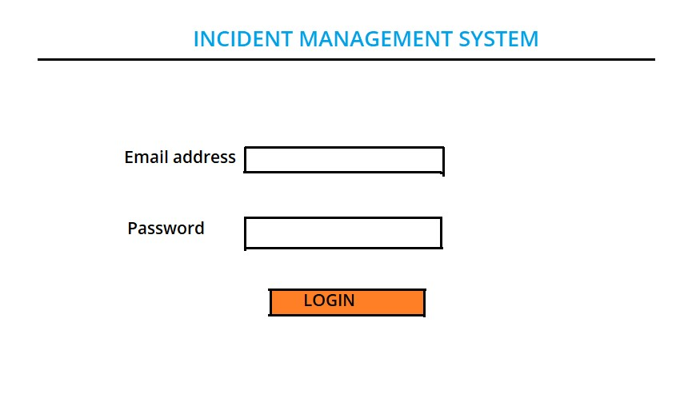

## DASHBOARD

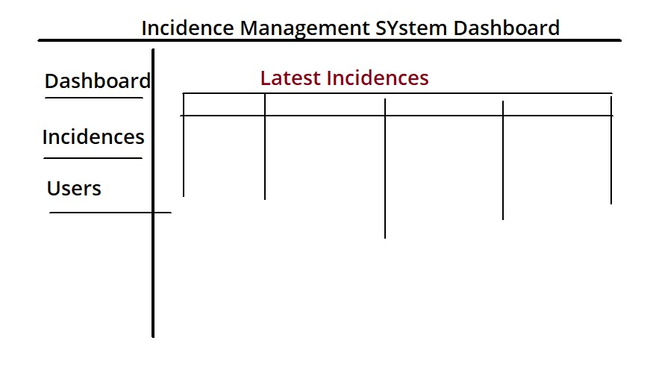

## INCIDENCE DETAILS

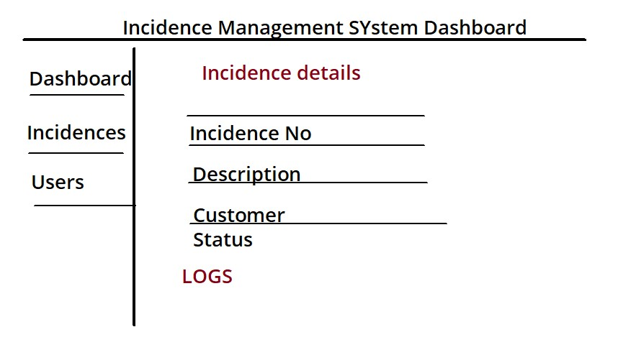

# SCREENSHOTS

## DATABASE USERS’ COLLECTION

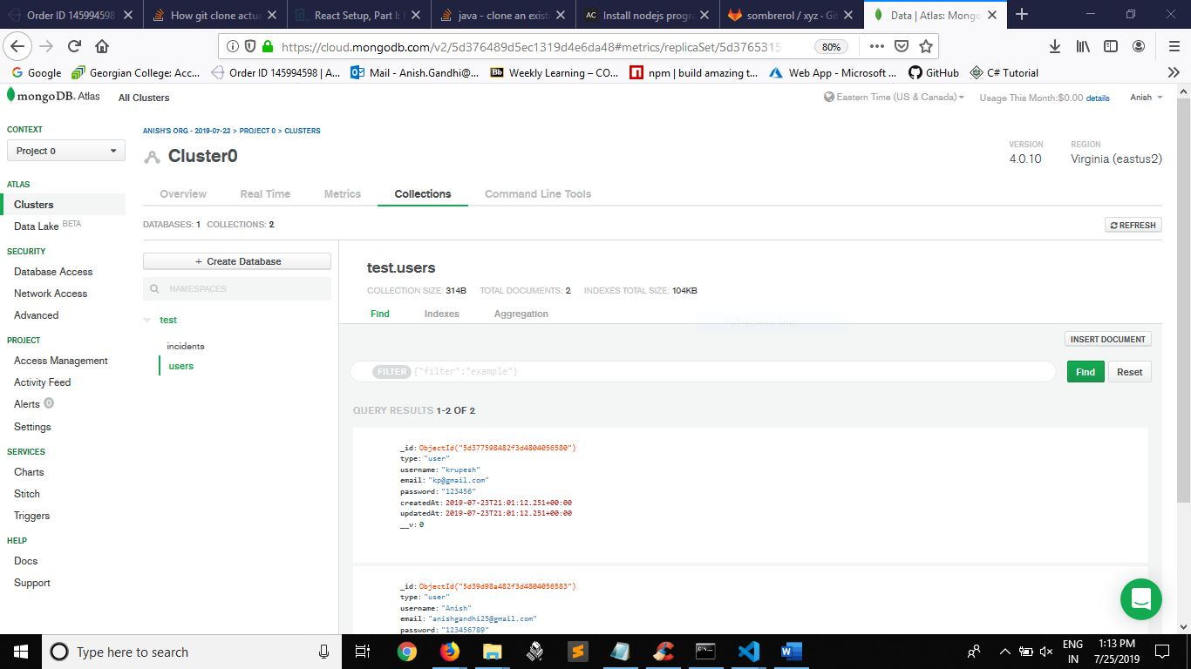

## INCIDENTS COLLECTION

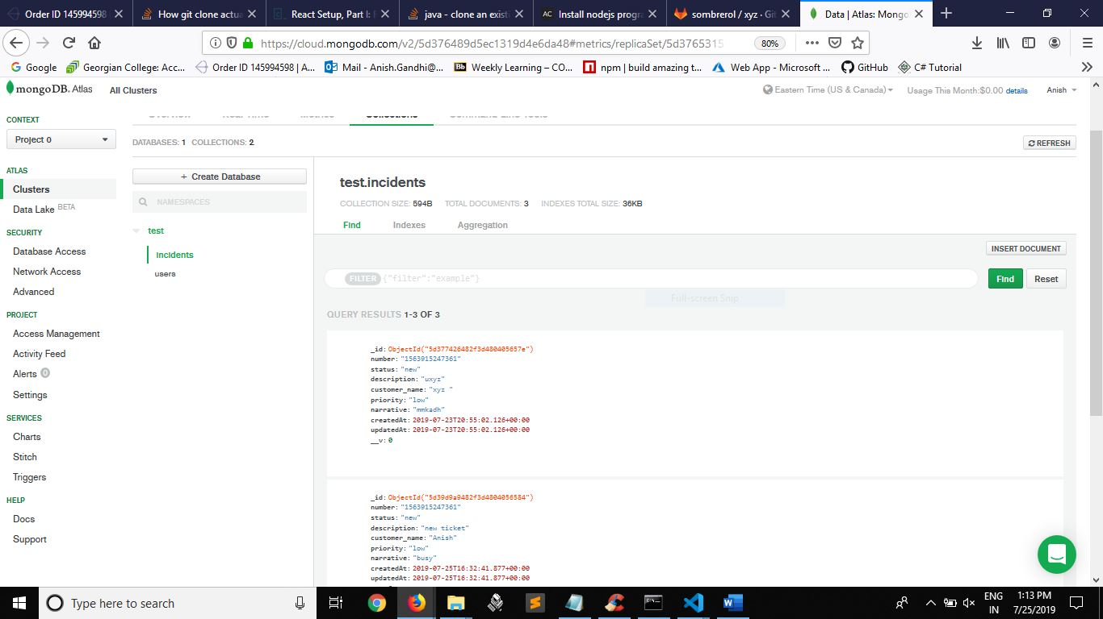

## INCIDENTS LOADED ON THE SYSTEM

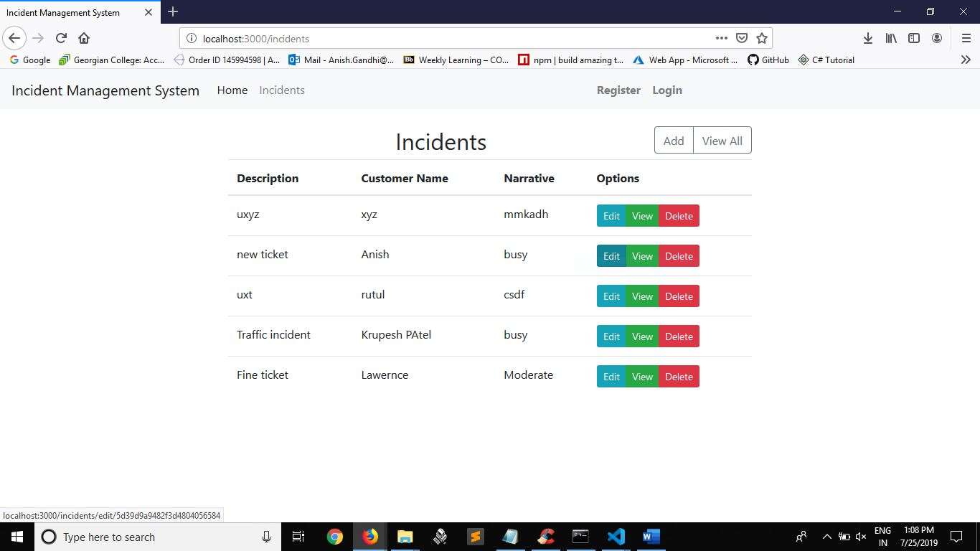

## INCIDENT DETAILS WINDOW DISPLAY

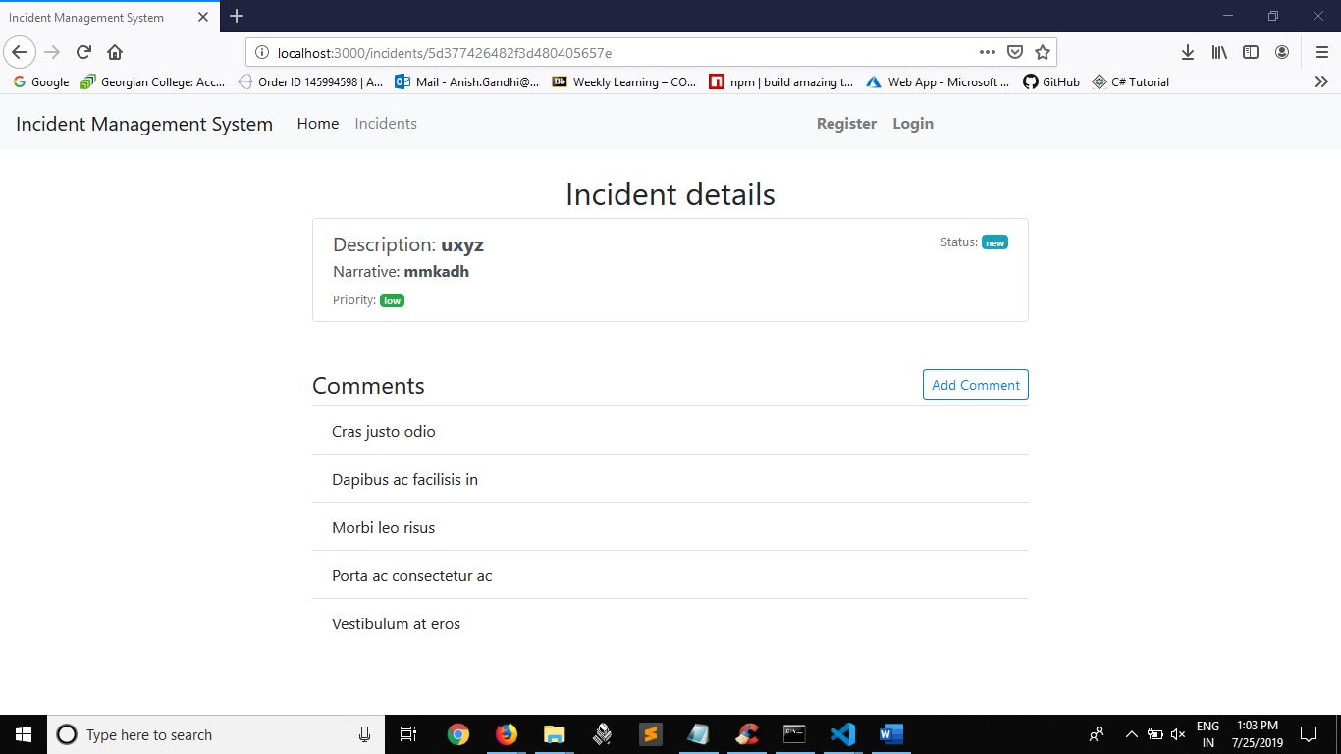

## INCIDENT CREATION WINDOW

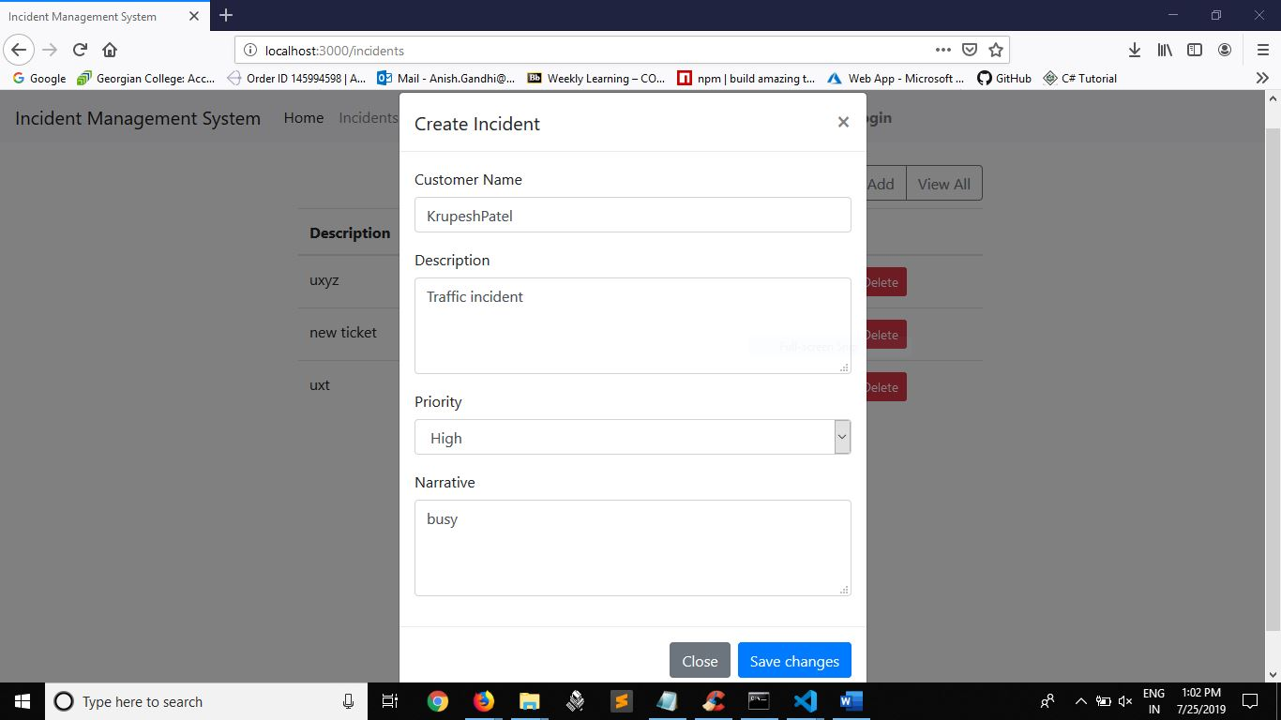

## USER ACCOUNT CREATION WINDOW

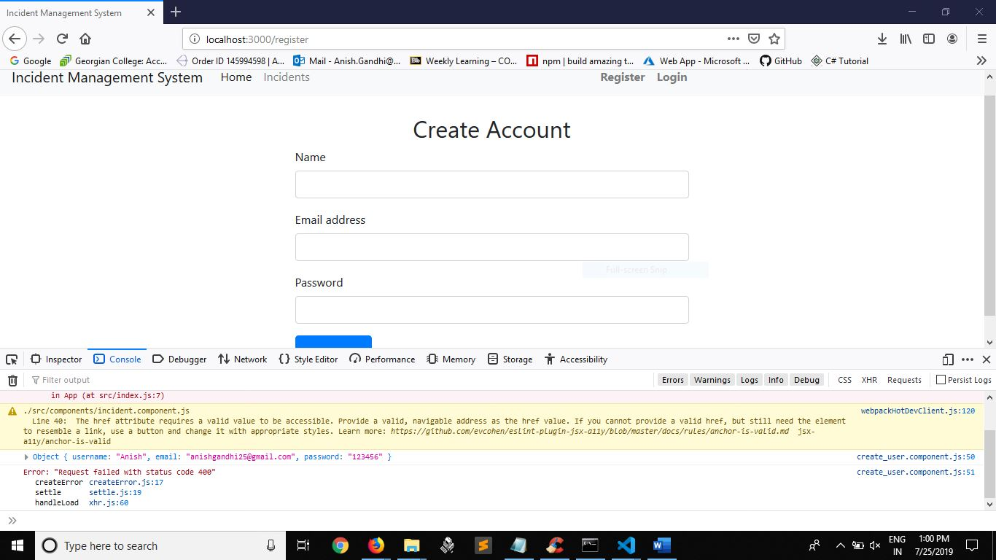

## DASHBOARD

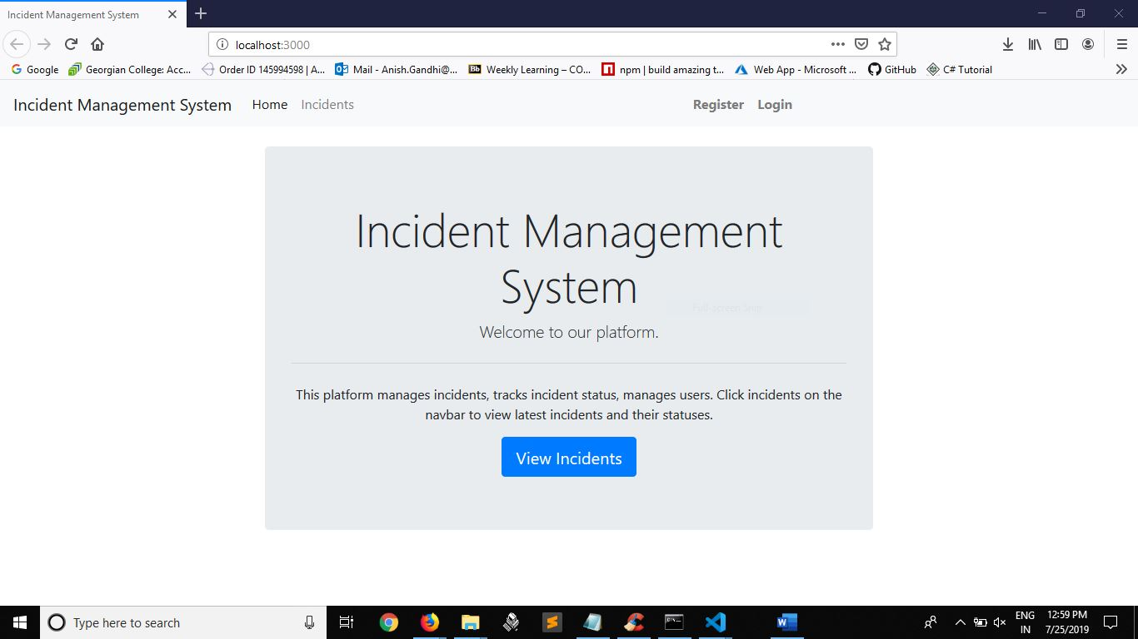

## CODE SNIPPETS

### INCIDENTS COMPONENT

|  |
| --- |
| *import* React,{Component} from 'react'; *import* axios *from* "axios";  *// import {Link} from 'react-router-dom';*    *export default class* Users *extends* Component { constructor(props){ *super*(props); *this*.state = { description:'', narrative:'', priority:'', status:'', customer:'', comments:[]  };    }    componentDidMount() {  console.log(*this*.props.match.params.id);  axios.get("http://localhost:5000/incidents/"+*this*.props.match.params.id)  .then(res=>{ *this*.setState({  description:res.data.description, narrative:res.data.narrative, priority:res.data.priority, status:res.data.status,  customer:res.data.customer_name  })  })  .catch(err=>console.log(err));  } |
| render() { *return* (  <div *className*="row">  <div *className*="col-sm-8 m-auto">  <h1 *className*="h2 text-center">Incident details</h1>  <div *className*="list-group">  <a *href*="#" *className*="list-group-item list-group-itemaction">  <div *className*="d-flex w-auto justify-content-between">  <h5 *className*="mb-1">Description:  <b>{*this*.state.description}</b></h5><br/>  <small *className*="text-muted">Status: <span *className*="badge badge-info"> {*this*.state.status}</span></small>  </div> <p *className*="mb-1">Narrative:  <b>{*this*.state.narrative}</b></p>  <small *className*="text-muted">Priority: <span *className*="badge badge-success">{*this*.state.priority}</span></small>  </a>  </div>  <br/><br/>  <h4>Comments  <div *className*="btn-group btn-group-sm float-right" *role*="group" *aria-label*="Basic example">  <button *type*="button" *className*="btn btn-outlineprimary btn-sm">Add Comment</button>  </div>  </h4>  </div>  </div>  );  }  } |

### INCIDENTS ROUTES

|  |
| --- |
| *const* router = require('express').Router();  *let* Incident = require('../models/incident.model');    *//Get all incidences*  router.route('/all').get((req,res)=>{  Incident.find()  .then(incidents=>res.json(incidents))  .catch(err=>res.status(400).json("Error:"+err));  });    *//Get all incidences not closed* router.route('/').get((req,res)=>{  Incident.find().where("status").in(["new",'dispatched','progress'])  .then(incidents=>res.json(incidents))  .catch(err=>res.status(400).json("Error:"+err))  });    *//get by id*  router.route('/:id').get((req,res)=>{  Incident.findById(req.params.id)  .then(incident=>res.json(incident))  .catch(err=>res.status(400).json("Error:"+err));  });    *//Add incident*  router.route('/add').post((req,res)=>{ *const* number = req.body.number; *const* description = req.body.description; *const* customer_name = req.body.customer_name; *const* priority = req.body.priority; *const* narrative = req.body.narrative; |
| *const* newIncident = *new*  Incident({number,description,customer_name,priority,narrative}); newIncident.save()  .then(()=>res.json('Incident added!'))  .catch(err=>res.status(400).json("Error:"+err));  });    *//Update incident*  router.route('/update/:id').post((req,res)=>{  Incident.findById(req.params.id)  .then(exercise=>{  *if*(req.body.description != *null*)  exercise.description = req.body.description; *if*(req.body.priority != *null*)  exercise.priority = req.body.priority; *if*(req.body.narrative != *null*)  exercise.narrative = exercise.narrative + ";"+req.body.narrative;    exercise.save()  .then(()=>res.json("Incident updated!"))  .catch(err=>res.status(400).json("Error updating record!"+err)); })  .catch(err=>res.status(400).json("Error!"+err));  });    *//Delete incident*  router.route('/:id').delete((req,res)=>{ Incident.findByIdAndDelete(req.params.id)  .then(()=>res.json("Incident deleted!"))  .catch(err=>res.status(400).json("Error deleting record:"+err));  });  module.exports = router; |

### BACKEND SERVER

|  |
| --- |
| *const* express = require('express'); *const* cors = require('cors');  *const* mongoose = require('mongoose');    require('dotenv').config();    *const* app = express();  *const* port = process.env.PORT || 5000; app.use(cors());  app.use(express.json());    *const* uri = process.env.ATLAS_URI;  mongoose.connect(uri,{useNewUrlParser:*true*,useCreateIndex:*true*});    *const* connection = mongoose.connection; connection.once('open',()=>{  console.log("MongoDB database connection established successfully");  });      *//>>>Model routers*  *const* userRouter = require('./routes/users'); *const* incidentRouter = require('./routes/incidents'); *const* commentRouter = require('./routes/comments');    app.use('/users',userRouter); app.use('/incidents',incidentRouter); app.use('/comments',commentRouter);    *//<<<<<<model routers* |

app.listen(port,()=>{

console.log(`Server is running on port: ${port} `); });

# FUTURE FUNCTIONALITIES

Customer login – Create accounts for customers

User editing, and delete – Add CRUD functionality for users

Incident deleting, updating, logs – Enable incident deleting, update and keeping of logs as a separate table showing who did what.

User roles matrix – Define roles and rights for users

## PROJECT URL

Azure Link: - <https://incidentsite.azurewebsites.net>

GitHub Repo Link: - <https://github.com/anish25/ExtraSeriousCompany>